**Title : EECS 1022 Lab 01 - BMI CALCULATOR**

**Passport York username : kumarraj**

**Full Name : Rajkumar Balakrishnan Lakshmi (213141197)**

**Introduction:**

In this lab our objective was to create an app that calculates the Body Mass Index(BMI) when a button is clicked. Android studio made it easier for us to build the app. The app consisted of two text boxes respectively for the user to input the height and the weight. It also consisted of an button, which on click calculated the BMI from the users input.

**Results:**

We first tested the model using public static void main, and the output was perfectly correct as expected.

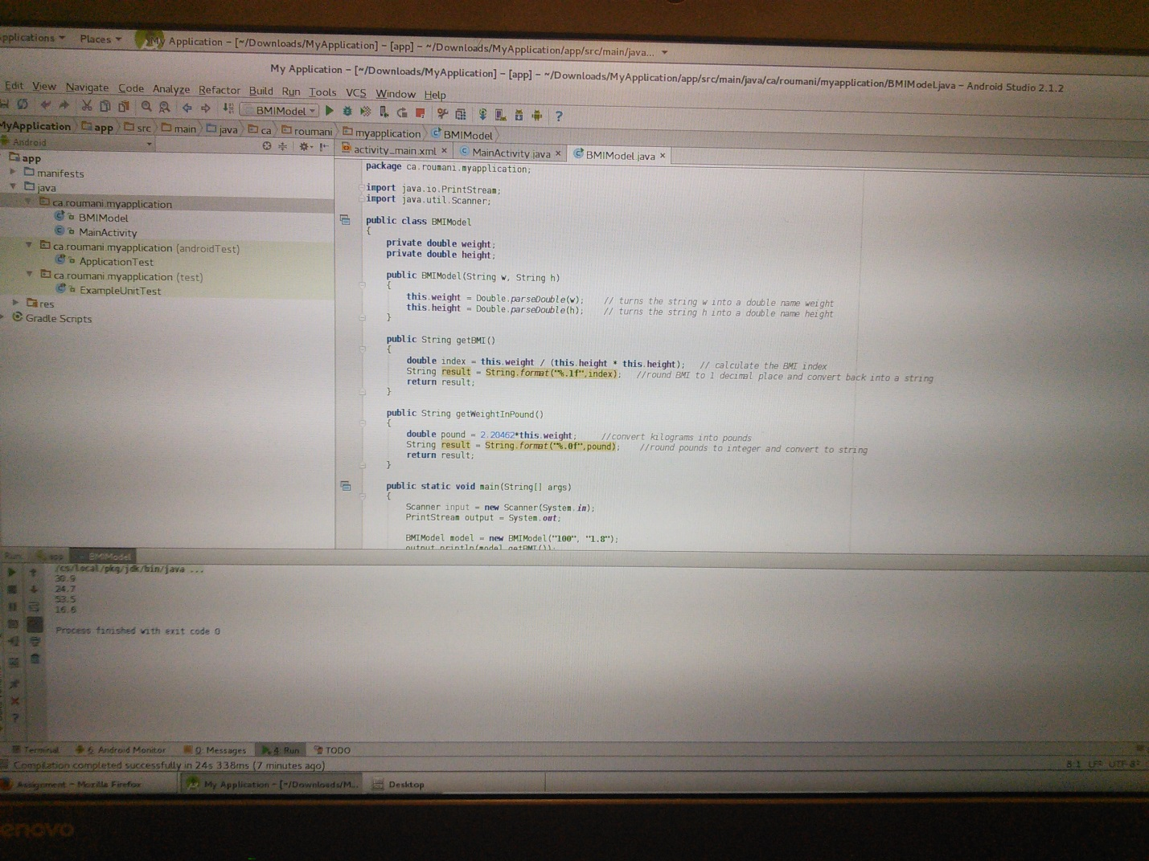

Later we deployed it on the android tablet, by connecting it to the laptop.

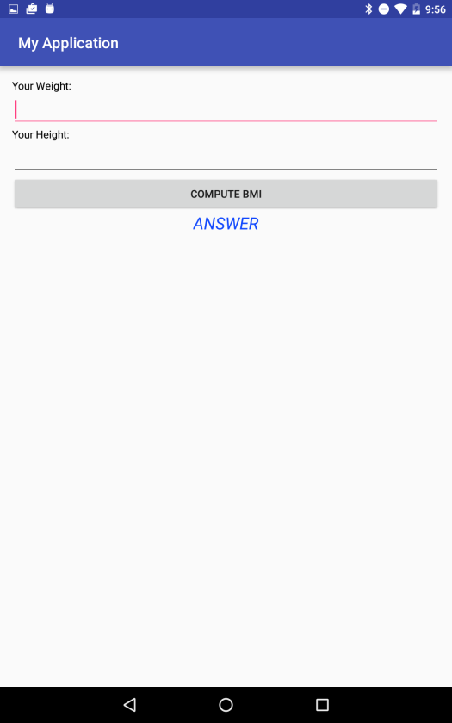

Screenshot after entering the height and weight:

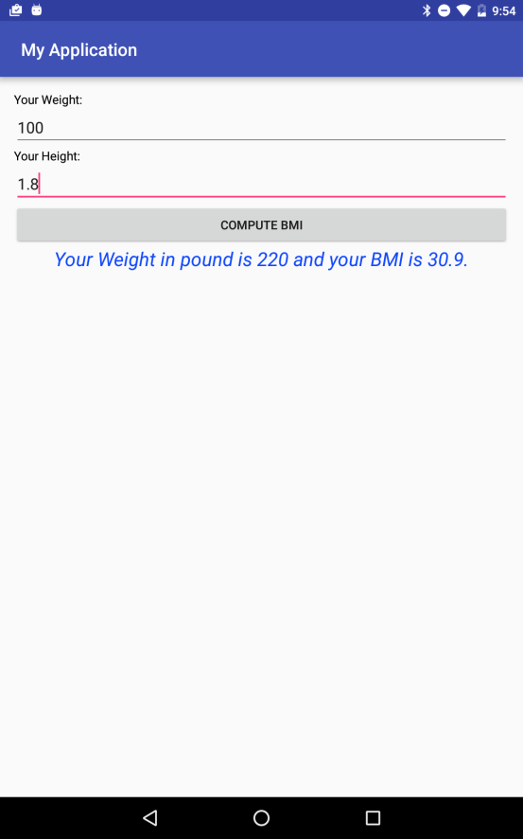

Herewith, I have attached the results and findings of this lab in the video format.

<https://youtu.be/wigdYqKsMEI>

**Discussion:**

Although the android studio was new to me, the walk through video posted by the professor helped me a lot in completing the lab. In particular the design option for creating the view of the app saved more time rather than typing the code itself.